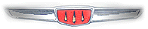

Good news for the “Brotherhood of the Three Spires”, we have been accepted by the Association of Rootes Car Clubs (ARCC) as the United States Hillman club affiliate. I had applied back in April/May and received notification in late June. I will keep everyone posted via this newsletter if there is any additional information.

Tigers East/Alpines East is having a large Sunbeam/Rootes show at Luray Virginia on September 14, 15, 16. There will be a Rootes show on Saturday and various tours along with an awards dinner on Saturday night, September 15. An application is attached to this newsletter.

Members: We keep adding new members and this quarter we have gained five. A big welcome to:

Jim D’Amelio, Hampton, VA 23666-2020

Tom J. Pearson, San Jose, CA 95132

Stark Shelby, Redmond, WA 98053

Charles M. Roper, Roswell, GA 30075

Mr. Christophe R. Rathbone, Fair Lawn, NJ 07410

Hillman Ads: Ads for Hillman cars or parts are free.

Wanted: Right Hand Drive Minx: Christopher Rathbone, 6 Burnham Pl, Fairlawn, NJ 07410 is looking for a RHD Minx.

For Sale: 4 Libre Gold 4 spoke alloy wheels, 13 x 5 ½” wide with 4 on 4 ¼ bolt pattern. Good condition with caps for center holes, $150. Contact David Pilpa-Augustyn at 1-626-584-6957

For Sale: Sunbeam Cars and Parts, package deal, cleaning out garage. 973-835-4870

For Sale: Reproduction floor pans for Series II Through V Sunbeam Rapier. $50 per pan or $200 for a full set. Gerald Shetler, 4793 Jody Lynn Dr., Mentor, Ohio 44060. Phone 440-257-1582 (Ed’s note: These should fit a Minx convertible without too much modification).

For Sale: 1954 & 1955 Hillman Minx Coupes, $500 each. Parts, parts cars, photo, transportation available. Dave Dawn, 201 Elizabeth St, SE, Albuquerque, NM 87123, phone 505-299-2901

For Sale: Sunbeam Imp collection. One restored Imp with concours paint job, one former rally Imp (w/history), two complete but unrestored Mk 2 Imps, plus performance parts, engines and more. $5,000. Clarence Harrison, Boulder, CO 303-258-7386

For Sale: 1957 Hillman Husky (project car), no engine or windshield. $750. car is in South Dakota. Contact 602-549-7968 (Tempe, AZ)

For Sale: 1961 Hillman Minx Convertible, car is in immaculate condition. 59K miles. $15,000 (Canadian) obo. 905-329-4179 (St Catharines, Ontario)

For Sale: 1961 Hillman Minx Convertible, restoration project, just cosmetics left to finish it off, original Arizona car, 99% rust free. $1,995. 480-836-7579 (Arizona)

For Sale: 1966 Hillman Super Minx, very original, driven regularly, $2,000 obo. 512-422-5050 (Texas)

For Sale: 1967 Sunbeam Funwagon Motorhome. Coachbuilt body on Commer chassis. $2,500. dwardon@qwest.net (Arizona)

For Sale: 1971 Plymouth Cricket: Needs restoration, $400 obo 316-536-2309 Kansas.

Car of the Quarter: The car of the quarter is the “car that was not supposed to exist”. That is, the Hillman Minx Series V. To understand this, we must go back to when the Super Minx was originally being designed. Based on auto industry averages of about 3 years to design a car (from start to production), work on what was to become the Super Minx must have started in the Summer of 1958. At that time it was called the Minx Series IV. As work progressed on this car, however, it was realized that the car was going to be too big and expensive to replace the Minx, therefore, it appears that sometime in 1960 a decision was made to continue the Minx and run the new, bigger car along with it.

Again, based upon the three year development cycle, work on the Minx to replace the Series IIIA/B/C must have begun in mid to late 1960. The basic Minx underpinnings were kept but almost all of the outer skin was replaced.

Up front there was a new grill. One that actually sat in front of the old grill opening. The fenders were kept, but the hood was lower. The front doors stayed about the same but the rear doors were redesigned to match the new roof line. The roof was lowered and the wrap around rear window was replaced with a new, flat style. This new rear window required the rear doors to have “quarter” windows. The old windows were shaped to fit into the doors and around the rear wheel cutouts in the door. The new windows couldn’t do this, so a small, fixed triangular window was added to the rear of the doors.

Finally, the small flipped over fins were removed and the rear fender was smooth back to the tail lights. To lower the car’s profile and to bring it in line with all of the other Rootes cars (except the Imp and Husky), the Minx now got 13 inch wheels to go along with a revised front suspension (ball joints top and bottom). The interior was modified also, the most notable change was in the dashboard. The instruments were now in front of the driver instead of in the center of the dash. Also, well padded bucket seats replaced the old bench seat. This made sense as a floor shift was standard.

Another major change was the use of a Borg Warner T-35 automatic transmission instead of the previous Smith’s Easidrive electric automatic. The new Borg Warner unit was to become almost universal in Europe, being used by Volvo and Mercedes among many others.

The Minx was almost a new car. It definitely looked more modern and the interior was also more up to date. The Engine was still the 1,592cc 4 cylinder introduced in the Series IIIC. Horsepower was unchanged at 62. Although Rootes called the car the Minx 1600 in its advertising, it had “Minx” on the doors instead of the “1600” that the Series IIIC had. The Minx did keep the chrome trim variation. When the car was a two tone model, the chrome side trim was two pieces separated by paint matching the color of the roof. When the car was a single tone, there was just a single strip of chrome down the side.

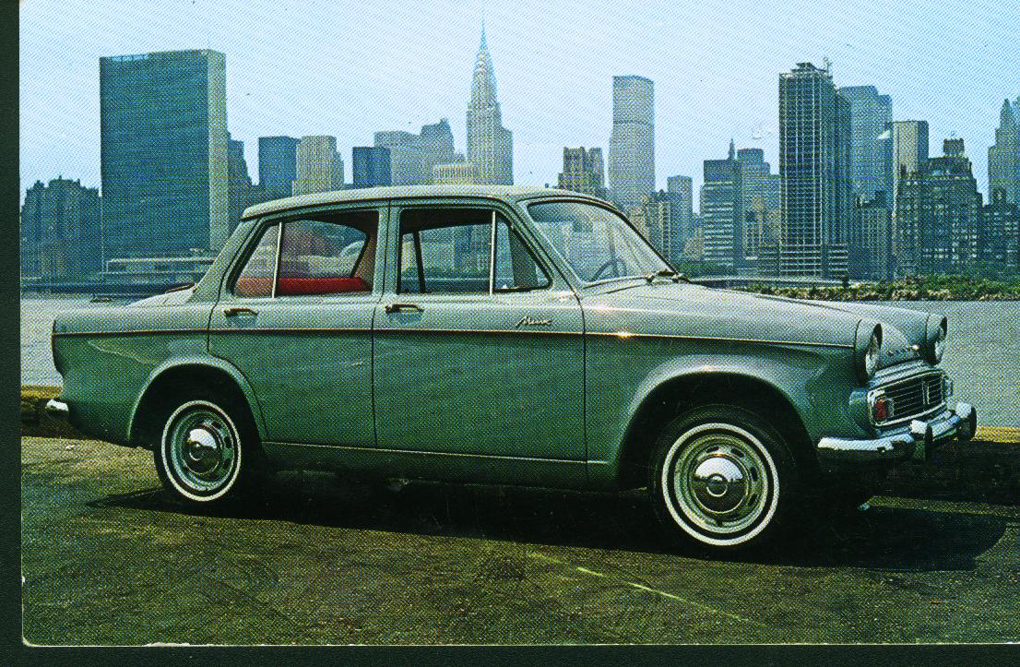
A Rootes “factory” photo of the Series V Minx. This photo was taken in Long Island City near the Rootes facility (that’s the New York City skyline on the other side of the East River). This is a single color car so there is only one strip of chrome down the side of the car.

The Series V Minx was to be the last Hillman Minx sold in the USA. It was introduced here in October of 1963 as a 1964 model and was sold through the 1964 model year. Then, through “badge engineering” it became a Sunbeam Minx Series V. Everything stayed the same, except that starting in late 1964, it had a new nameplate. It also got the new fully synchronized transmission, first was no long a “crash” gear.

That the new model came out at all was amazing. Rootes had just spent a large amount of money developing the Super Minx and an even larger sum of money on the “Imp”-not only on the car, but also on a new factory. Rootes had somehow been able to develop three new cars almost simultaneously. This was quite an achievement for a company the size of Rootes.

The year 1964 was a good one for Rootes. They produced a whopping 228,562 cars, an all time record. Of these, 157,639 were for the home market and 70,923 were exported. Rootes now had 12.2% of the British market, not their highest share ever, but better then the five previous years. Of these 228,000 cars, about 165,000 were Hillmans. However, for all of this effort, Rootes only made a profit of 1.5 million British Pounds for the year. This was better then their losses of the previous two years, but it was still not a lot of money. Particularly when you consider that 228,000 cars and trucks was an all time record for Rootes.

I do not have any figures on Rootes sales in the USA for 1964. In 1963 they sold 6,000 cars and in 1966 they would sell 8,518. So it looks like sales were somewhere between those two numbers. They definitely did not sell 10,000 cars as that would have put them in the “top ten imports” and they were not on the list.

The price of the Series V Minx rose to $1,739 (from $1,699 for the Series IIIC). The Borg Warner automatic added $199 and air conditioning was still listed as an option. However, I have a New York Times article that says the price of the new Hillman Minx with a Borg Warner automatic was $1,998 on October 16, 1963.

Compared to American cars, these were very good prices. A new 1964 Chevy II 2 door sedan with a 6 cylinder engine and a manual transmission cost $2,206 (or nearly $500 more then a Minx). There was a 4 cylinder version of the Chevy II, but only 800 were sold (compared to 190,900 sixes). An automatic added $188 to the price.

But…. A 1964 Volkswagen base model cost only $1,563 and Volkswagen sold 371,222 cars in the USA in 1964 compared to less then 10,000 cars by Rootes (and this includes Alpines!).

The next issue will cover the Husky Series III.

