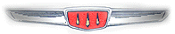

Notes from the editor:

You find in this issue a three page flyer for the North American Hillman Gathering III to be held in the Seattle area on July 25th through the 27th. If you attended any of the past five Hillman meets, you know how much fun this will be! Our West Coast coordinator, Craig Burlingame has planned and hosted two prior North America Meets out there so he has had experience doing this and it gets better each time!
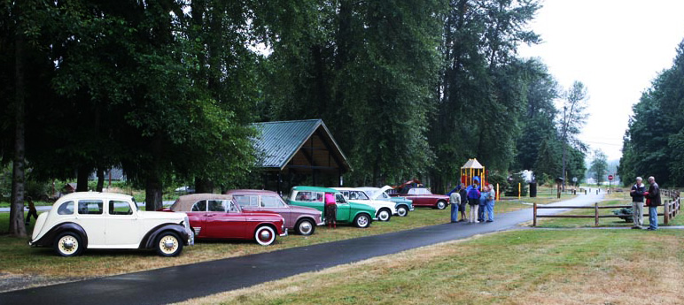

A line up of Hillmans at the 2008 event.

A wide range of events are planned and you can come with or without a Hillman. All other Rootes four seaters are welcome in addition to both "Husky sports roadsters" and "V-8 powered Husky sports roadsters". Maybe this year we can get a Humber or two!

Rootes United XXXIII

If Seattle is too far west for you, there is another show a bit further east… the annual Tigers/East Alpines/East club will hold their "United" meet in Michigan this year. It should be easy enough to remember, three "X's" followed by three "I's"! Mark your calendar for September 11 to 14, 2014. Location will be the beautiful Boyne Mountain Resort in Boyne Falls, Michigan. Hillmans are ALWAYS welcomed at the Rootes United meets (they were once upon a time called "Sunbeam United"). I have attended not only with various Hillmans but also with my Plymouth Cricket (this was possibly the only show I have ever attended where almost everyone knew that a Cricket was a Hillman). Be prepared to have one heck of a good time. I still remember the "United" in 2001 where we closed down the restaurant singing Thom Lehrer songs all night!
For more details and registration, go to rootesamerica.org on the internet.

For Sale:

1959 Minx sedan, no engine but has gearbox in place, CA title, rusty front floors but solid shell. Asking $900.

1959 Singer Gazelle sedan and 1960 Minx sedan selling as a pair. Both no engine, rusty front floors, rust on rockers, poor interiors, bad windshileds and many small parts missing. Singer has MI title but Minx has none. Asking $500 for both OBO.

Parting out 2 Sunbeam Alpines, rotten bodies but repairable fenders, two sets of doors, windshield from earlier Alpine, no engines or trans and no interior. No top or frame. One set of alloy/mag wheels and a few 13 inch wire wheels. Tail lights for high finned model Alpine.

Contact Tony at 219-718-7335 or e-mail to tonybcc56@hotmail.com

1964 Hillman Super Minx convert in very good overall condition, plus 63 Super Minx sedan for parts. May trade for Hillman Imp. CA. Contact rcanipe@att.net

Wanted:

Tail lamp assemblies or lenses for '58 or '59 Minx, Center gearshift gearboxes or shift gate for '58 through '60 Minx, Good sedan or convertible interior (mainly seats) for '58 or '59 Minx. Contact Tony at 219-718-7335 or e-mail to tonybcc56@hotmail.com

Speedometer Cables:

Over the next few issues I will be talking about Hillman instruments. This issue is going to start with speedometer cables. The good news here is that the ends of all of the cables from the Mark VI of 1953 through the Sunbeam Arrow of 1969 are all the same. The difference is the length of the cable. The only later car using a cable with different ends is the Plymouth Cricket. In addition, the Hillman shares its cabl;es with Sunbeam Alpines.

The two major sources for Sunbeam parts, Classic Sunbeam and Sunbeam Specialties both have cables from Alpines that can fit your Minx or Husy (or Arrow). In addition, Moss Motors has cables for many British sports cars that also fit. The key to all of this the length of the cable. The longest cable used in any Hillman/Sunbeam Arrow is about 6 feet long. The one exception is the Mark I Husky which uses a 7 foot long cable. The Alpine Series V with a manual trans (not overdrive) uses a cable 6 feet 3 inches long. This will work well in any Minx or Husky except for the Mark I Husky, then use a cable for an Alpine Series III or IV.

The Phase II through Mark V use a 6 foot long cable, but the threads on the connectors are different. The Cricket uses a the same screw connector at the transmission as the Series Minxes and Arrow, but has a special "push-on" type connector up at the speedometer. These are more difficult to find and are not interchangeable with any Sunbeam.

If lubricated these cables will last a long, long time. If the cable breaks, it is possible that the problem is in the speedometer head and replacing the cable with simply result in a second broken cable. It does make sense, however, to periodically lubricate the cable with graphite lubricant (a black/gray powder that is very fine and seems to get everywhere). In addition, if a cable has broken, the entire cable should be replaced, not just the inner cable. Why? Because the broken end of the cable, driven by the transmission gear, will spin and possibly leave burs on the inside of the outer housing. These burs will wear through the new inner cable pretty quickly.

When replacing a cable, note that there are tabs welded to various points under the body that hold the cable in place. Bend them back and slide the cable under them and then bend them back into position. Also, be VERY careful when routing the cable on the firewall. The Minx and Super Minx steering gear "cross rod" can "pinch" a cable. The cable must go in the extreme corner.

It should be noted that the two ends of the cable are different. The end of the inner cable up at the speedometer has either a brass ring or a nylon bushing on it. Sometimes the cable can slip down in the nylon bushing. When this occurs, the cable end pops out of the speedometer and the speedometer stops working. Repair is straight forward, disconnect the cable from the speedometer, pull the inner cable up out of the housing a few inches, push the nylon bushing back down on the cable, feed the inner cable back down into the outer housing (the other end of the cable has to mesh with the driven gear down at the transmission, so you may have to both rotate the inner cable and push it down to get it back into engagement). Then reconnect to the speedometer head. I have never seen one of the brass rings allow the inner cable to slide down, they seem to stay in place, but it could happen. The brass ring is found on the older inner cables. All Phase and Mark cars use the brass ring retainer. Later Series cars use the nylon bushing.

Down at the transmission, the inner cable is squared off and goes into the drive gear on the transmission tailshaft. The outer cable has a threaded coupling that screws onto the threaded section on the rear side of the tailshaft. This gets screwed on hand tight. If it leaks, tighten it slightly with a plier.

In the next issue we will move up to the speedometer itself and determine what the calibration is.

