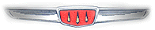

Notes from the Editor:
Well its summer and time to take your Hillman out and enjoy nice drives in the country and maybe attend a few car shows or cruise nights. There are two local cruise nights that I take my Hillman to whenever I can. Both are quite local (5-10 miles from home). It seems with each cruise night I get another Hillman admirer! So wash the Hillman and get it out to those meets.

Also thanks for all those stamps! That will definitely keep “Melodies” going for at least a year. Those of you that sent money-I used it to buy more stamps (forever stamps of course in case the rates go up!).

I also heard from a fellow who grew up in Iran and is very fond of Paykans. He is so fond, in fact, he bought a Singer Gazelle over to the USA from England just so that he could have one here. Paykans were Hillman Hunters (known in the USA as Sunbeam Arrows) that were built in Iran from 1967 to about 2007 (that is not a misprint, you could buy a NEW 1967 Hillman as late as 2007 in Iran).

Finally, Hillmans received some nice publicity in “Old Cars” newspaper, a weekly newspaper on the old car hobby. The latest (June 23, 2011) issue has a two page spread on “The Mini Minx” along with two factory photos of Series IIIA Minxes. Thanks to Verne Hillman and Chuck Hillman for copies of the article!

Hillman Ads:
Club Literature-90 pieces of:
“The Alpine Marque”
“Rootes Review”
“Tigers East/Alpines East”
“Rapier News”
“The Oily Rag” (from Canada)
also
“Car and Driver” June 1961 and April 1962
“British Car” Jan 1997 and Jan 1998 all with articles on Sunbeams.
The asking price is $10 plus shipping for all of this stuff. Contact warrenworks@yahoo.com

1958 Minx Convertible
I bought it out of Colorado, as a non-runner. Brakes rebuilt, tranny replaced, engine purrs... well, like a minx. This one is a good runner. It runs and drives like a champ. 1958 Series II with a few mismatched trim bits from a Series I sedan. NOS Gazelle taillights, a Rapier fuel filler, a spare trans that's set up for an overdrive, probably throw in a Rapier twin-carb manifold set and air cleaner bits. There's a little rust, but very little. The worst damage is the driver's door - it got overextended forward at some point, damaging the door and the wing. It still opens and closes normally, though. All the glass is intact, the top frame is incomplete but I have 2 spare frames that go with it. The brakes are done from master to drums, new hoses, new cylinders where possible and rebuilt where necessary.
Jon & Eileen Arzt
14015 Marinda Plaze Apt 4
Omaha, NE 68144

1959 Minx Series III Special Sedan
This is a black car with a dark red interior. It has been repainted and the seats have been repaired (not replaced or redone), it has a completely new brake system (all cylinders, shoes and hoses), new clutch disk, pressure plate and throw out bearing and clutch hydraulics. New front and rear window rubber seals, new floor mats and interior door panels. It has a brand new NOS Motorola Positive ground AM radio with the antenna mounted on the rear bumper. Car has NO rust anywhere and starts, runs and drives like new, cruises happily at 60 MPH. Asking $2,500-call Jan Eyerman at 973-584-8476 (New Jersey)
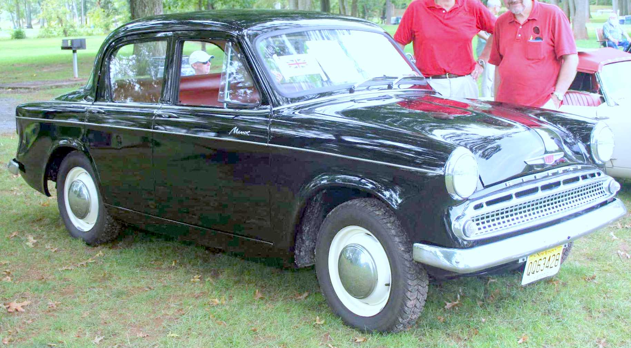

Electronic Ignition:
In two previous newsletters I wrote about vacuum advances and electronic voltage regulators. In this newsletter I will talk about replacing your distributor’s points and condensor with an electronic switch. The most famous (and common) unit is a part called an “Ignitor” that is made by a company called “Pertronix”. There are a number of variations of this unit and you must be careful to get the right one for your car.

First, however, I will explain what it does and why you would want one. The Pertrtonix unit directly bolts inside your distributor and replaces the points and condensor (you will still need your rotor though). In addition, there is a ring that slips over distributor cam. How well your engine runs is heavily determined on something called “point dwell” and how exact the timing is. The design of the Lucas distributor in your car is such that a certain amount of wobble in the main shaft is almost inevitable. This causes both the “dwell” to vary and the timing to vary. In addition, at higher RPM’s a set of mechanical points gives a poor spark. Finally, points wear out and have only a limited capability to handle more power (current). The “Pertronix” unit eliminates all of these problems as any wobbling of the distributor shaft has almost no effect on the unit. In almost every case that I have installed a Pertronix unit I have seen a substantial improvement in how the engine runs. It definitely runs smoother. The ring you put on the distributor cam is made of plastic and contains four magnets, each one is located at one of the lobes of the distributor cam. The part that you bolt in place of the points in the distributor actually contains a transistor that can sense the magnets. When the transistor “senses” a magnet nearby it “fires” the ignition. The unit is not effected by small “wobbles” of the distributor shaft (which has a BIG effect on regular points) and can easily handle much more power (current) then a regular set of points. It also doesn’t wear out the way points do. This allows you to use a more powerful coil (Pertronix makes a 40,000 volt “Flamethrower” coil that replaces your standard 20,000 volt coil).

There is a downside. You will no longer be able to set the timing using a simple 12 volt bulb, you will have to use a timing light. (the kind that connects to #1 spark plug and flashes at the timing marks on the front pulley).

OK, now for which Pertronix unit to use. Unlike points which are not sensitive to the electrical polarity of the car (that is which battery terminal is grounded), incorrect connection of the Pertronix will destroy the sensitive electronics inside it.

Over the years Hillmans (and Sunbeam badged Hillmans and Plymouth Crickets) have used three different kinds of Lucas distributors. Starting off, the 1949-55 “Mark” cars with the flat head engines used a Lucas model DKY4A. Unfortunately there were two versions of this distributor, one with a code number ending in A-D and one with a code number ending in E-Z. If your car has one with the A-D ending, order a Pertronix Ignitor LU146MP12 (the P12 indicating 12 volts, positive ground). If you have a distributor with a code ending in E-Z order a Pertronix Ignitor LU146P12. The code is a four or five digit number followed by a letter stamped on the outside of the distributor. The Husky also used a DKY4A distributor and uses the same Pertronix unit as the Minx.

Starting with the Mark VIII with an overhead valve engine, Hillman began using a Lucas type DM2P4 distributor. For these use a Pertronix Ignitor part number LU241LSP12. The Series I through Series IIIC used the same Lucas DM2P4 distributor but were slightly different and use a Pertronix part number LU149P12. If your car has been converted to negative ground, just drop the P12 from the part number and you will get a negative ground Pertronix unit. Again, the Series I & II Husky used the same distributor as the Minx I-IIIC.

Starting with the Series V Minx and including the Series III Husky, Sunbeam Arrow and Plymouth Cricket, Hillmans used a Lucas 25D4 distributor. If you car is a positive ground car, use a Pertronix LU142AP12 unit, if your car is a negative ground car, use a Pertronix LU142A (without the P12).

As note, you might run across an older Pertronix LU142 unit, don’t use it as these had a number of problems and were replaced by the LU142A units.

When installing, just follow the instructions that come with the unit, keeping in mind that electrical polarity is very important. In addition, be absolutely sure to save and file away for safe keeping your bill/receipt for the unit. Pertronix offers a lifetime warranty, but absolutely requires the original bill/receipt to replace the unit. I know this as a pertronix unit failed on me on the way home from the 2007 Hillman Meet in Ohio and later when I tried to get it replaced, they required the bill.

Pertronix Ignitor kits cost about $75-100 depending on where you get them, I also recommend getting a Pertronix “Flamethrower” coil (part number 28010 or 40501 or 40511-chrome).

Finally, one last disclaimer. While I have used the Pertronix unit extensively over the years, I have had them fail. They will fail suddenly and totally, leaving you dead stopped somewhere. In my case it was a toll booth on the Ohio turnpike coming home from the 2007 Hillman National Meet in Streetsboro, Ohio, about 350 miles from home. It is suggested that you carry a set of points and condensor that would allow you to convert your car back to mechanical ignition. I go one further, I have complete, tested, functional distributor in my emergency kit. In less then five minutes I can have the old distributor out and the new one in and timed and ready to go.

One of the tricks on the OHV cars for setting the timing is that the vacuum advance body is exactly parallel to the engine block when the timing is set correctly with four lines showing on the vernier adjustment on the vacuum advance. This will give you about 11 degrees of advance.

The ultimate way to go is to just buy a complete, new distributor from Pertronix (cost is about $200). These are simply drop in units. For the OHV cars only (replaces both the DM2P4 and the 24D4 distributors) order either D176600 for Negative ground cars or D178600 for Positive ground cars.

As a by the way, the Pertronix unit will work fine with a Smith’s tachometer and I can assure you that your car will definitely run better with a Pertronix installed. Finally, the Petronix unit is completely “invisible” when installed, there is nothing outside of the distributor to show that the ignition has been modernized. As I noted, the wiring of a Pertronix is different from a set of points, so follow the instruction sheet when you install. Another note.. Lucas Coils have “SW” for the connector for the ignition switch and “CB” for “contact breaker (points) for the wire going to the points and to ground. So on a positive ground car “CB” is the negative connection (-) and “CB” is the positive connection (+).

Smith’s Clock Upgrade
While I sort of like the “jeweled” Rootes Group device on the dashboard of my 1962 Minx 1600 Series IIIC convertible (what a mouthful!), many times I have yearned for a Smith’s clock that belongs in that spot. However, every Smith’s clock I have found has been “DOA”. However, recently Doug Lyle, a long time Sunbeam-Hillman collector recommended Mike Eck for a crystal controlled (Quartz) repair/upgrade for your Smith’s clock. If you don’t have a clock in your car, this would be a good source for something to replace that plastic “Rootes Group” emblem in your dashboard.
To do this you will need a non-functional (or functional) Smith’s clock for your car. I have had no problem purchasing non-functional clocks at British Car swap meets or flea markets for a dollar or two. The upgraded clock will fit either a positive or negative ground, it is totally self-contained and will look and function like the original. Cost is $100 for the upgrade and includes return postage. Package you old clock carefully and send it along with your name and address, e-mail and the polarity of your car (positive or negative) along with a money order for $100 to
Mike Eck
71 Hillcrest Road
Martinsville, NJ 08836
Give Mike a few weeks to “do his magic” to your old clock.

