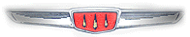

Notes from the Editor:

Well Winter is upon us and my Hillmans are tucked away until Spring. Included in this issue are some good instructions on storing your car for the winter. I strongly advise disconnecting the battery as electrical fires are not unheard of. If your car is going to be in an unheated garage, it would also make sense to bring your battery inside to keep it from freezing. I lost a battery on my lawn tractor that way last year. In this issue I will also discuss shock absorbers. And to start off with, our featured Hillman is a car shown a few issues back, but now in a new guise.

Car of the Quarter:

Steve Silverberg’s daughter Clara “did up” her father’s Minx for the Marlborough, Massachusetts labor day parade. To quote Steve, “Ok, now I am laughing.... sort of to my dismay I can't believe the reception the Minx has gotten. It was on TV tonight (the local broadcast station) and the announcers were all about the Minx. Amazing. The Marlborough Labor Day Parade is a larger event for the city and draws multiple marching bands from all over, Clydesdale pulled wagons, military re-enactors, etc. Surprisingly everyone loved the car. Ellen said people were coming out into the street to take pictures and asking about the car. Clara, my daughter, carried the banner for the Metrowest Animal Awareness Society. She sewed up most of the pieces for the car costume. No, that's not me
driving... sorry...I couldn't "man-up" to that job.”
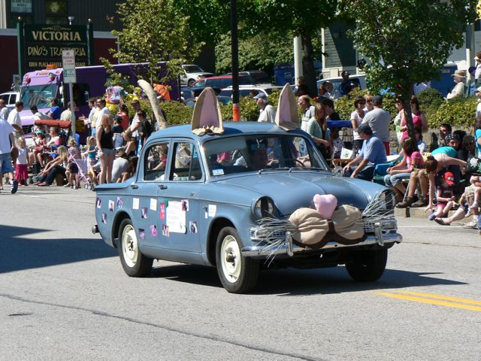

Hillman Shock Absorbers:

Over the period 1948-1973 Hillman used three kinds of shock absorbers. These more or less followed the overall Auto Industry. Starting with classic “lever action” shocks from 1948 through 1956 and then moving to “aircraft style” shocks and ending with Macpherson struts (as used on most modern cars).

Lever action shocks need to have their fluid level checked periodically. There is a filler plug on top that can be unscrewed and the fluid should come up to the bottom of the hole. Fortunately, the fluid is still being sold by Moss Motors (part number 220-304) and costs $16.75 a pint (but you won’t use very much). Moss’s phone number is 800-667-7872. Say it is for an MGA. An alternative is to use Harley Davidson (motorcycle) front fork oil. But this will make your shocks somewhat stiffer. If your lever action shock is shot, then you need to send it to Apple Hydraulics, a company that specializes in rebuilding lever action shocks. Rebuilding costs between $75 and $100 per shock. Note that a Mark Hillman has 4 different shocks-left and right and front and rear. An Alpine Series I & II might substitute for a rear shock (and possibly for front shocks) if you are missing one.

The “aircraft style” or sometimes called “tubular” shock was used on the Series Hillman Minx. For the Series I through IIIC Minx (and front shocks on the Series I-II Husky) a shock with stud mounts on both top and bottom was used. The compressed length was 7 ½ inches and the extended length is 11 ½ inches. OEM shocks are no longer available anywhere except as leftover NOS (and quite hard to find). I have used shocks for a 1976 Chrysler on mine, the Monroe part number is 31176 and seems to work quite well. For the rear on sedans and convertibles, the shocks are 12 inches compressed and 21 inches extended. I have used shocks for a 1966 Ford Mustang, Monroe part number 31069 on my car with no problems. The Husky I-III uses a lever action shock on the rear and I suggest Apple Hydraulics again or, if you have no shock, use one from a Series I or II Alpine.

Moving on to the Series V and VI Minx. The usual parts suppliers for Sunbeam Alpines can provide front shocks (Sunbeam Specialties, Classic Sunbeam Parts and Victoria British) for Series IV and V Alpines, these will fit and cost appears to be about $25 each.

If you need rear shocks for your Series I-IIIC Estate Wagon or for your Sunbeam Arrow sedan, try 1970 Ford Galaxie station wagon shocks, Monroe Part number 33049.

Starting with the 1967 Sunbeam Arrow sedan, Rootes went to Macpherson struts up front. Unfortunately, these are generally no longer available. The only possible source is from Iran (no kidding). Front strut inserts from a Paykan will fit. But these are also very, very difficult to obtain. It is possible that Speedy Spares or Alpine Midlands in England might be able to provide something (note that front strut inserts from a Sunbeam Rapier fastback will fit).

Finally, for struts for a Plymouth Cricket, you are out of luck in the USA. However, strut inserts might still available in England. Again, Speedy Spares and Alpine West Midlands would be the companies to check out. Remember that the Plymouth Cricket was called the Hillman Avenger over there. While I do not have any information on rear shock absorbers, NOS does seem to appear on the internet peridoically.

Storing Your Hillman For The Winter:

The following are suggestions for storing your Hillman over the coming winter months. Frank French is a member of the British Saloon Car Club of Canada and recently posted these suggestions.
With today's fuel supplies it's a very good idea to do at least two things, fill the tank to help prevent condensation in the tank itself and use a fuel stabilizer. There are a number of brands out there, Eastwood.com sells Fuel Guardand and Sta-bil Fuel Stabilizer is available at Walmart and many other auto parts places as well.
Check the anti-freeze because many Brit heaters can't be drained so it's a good idea to have good anti-freeze in the car. How many of us actually change the antifreeze according to the manufacturers? The average age should be no more than two years though there's a lot of debate there.

Oil, some say change it before putting it away and some say after it starts in the spring and there are those (with more money than I have) who do both, change it in the fall and again in the spring. Also some people will pull the plugs and put some light oil or Marvel Mystery oil in the bores and put the plugs back in. Cover up the tail pipe too, but again if you don't remember that you did that it might come back to haunt you. Of course you can always make a check list and leave it in the car of things to do in the spring.

In humid areas some people will coat all the chrome with Petroleum Jelly, and don't forget the back side of the bumper and give it a shot of an oily rust preventative if you can get at it. . After checking out the chrome don't forget the rubber seals, GM sells a version of Dupont Krytox (which sounds pretty Toxic which might be why they called it what they did) The part number I've seen is GM part number 3634770. Not cheap but a little goes a long way and rubber seals on our cars are not cheap.

Battery, removing it is the best bet unless you want to start the car up during the off season. There's even more debate about that for those of use with a crank you could leave the plugs loose and come out and give it a spin every once in a while which would lubricate things with out any combustion. The battery will last longest if you make sure the levels are good (if you can check) and either charge it up once in awhile or get a smart trickle charger (see note below), Battery Tender is one brand.. I used to put the batteries in the tool shed over winter and put them in the car in the spring with a fresh coating of jelly on the posts. Supposedly standing the battery on concrete kills battery has been proven a myth but our shed had a wooden floor and big windows.

There can be a problem with rodents so there are commercial baits and poisons but a lot of guys I know use Dryer Sheets, supposedly the rodents don't like the smell any more than us manly men do. The only down side is the car smells lovely and fresh come spring. Just kidding but there are other solutions out there, just takes a bit of research. (editor’s note, I use moth balls).

And about the last thing I can think of is wheel bearings and a tires, some will put the car on jack stands to take the weight off the suspension. Others have to move the car around so they buy a set of four wheel dollies that cradle the wheel which helps the tire but may not do anything for the bearing. I think I'd be more a put it on axle stands kind of guy.

To finish off there are also people who drive it into the garage and shut to door and drive it out the next spring and don't do any of the above. So find a happy medium that you can follow and go for it. Though I will say I have a friend with a lot of LBC's and his MGA was in storage for two years and started and ran and all he did was put in stabilizer.

Hope this helps.., Frank French

Note: There have been some explosions and fires due to “battery tenders” and trickle chargers. I recommend disconnecting the battery to prevent any electrical problems and recharging the battery once or twice during the winter.

Second note: Ian Cox, also of the British Saloon Car Club of Canada stated that there are two kinds of formulas of fuel stabilizer, they are red and blue. The blue is designed for marine use. That's the one to get. The red is designed for modern sealed fuel systems, which your Hillman does not have, anymore than just about any old classic car. The marine use stabilizer is not affected by evaporation and dampness. That's the advice I have received from the manufacturers. Ian

Some Thoughts On Car Shows:

If you haven’t taken your Hillman to a car show, you are missing out on a lot of fun. Although I have a case of trophies for my various Hillmans, I really am no longer interested in winning anything, I now go for the fun of it. First of all I suggest you make up a sign explaining what a Hillman is (imported from England, etc.) and another one giving whatever history of your car that you know. I joke that my two signs on my car are the most read signs at the entire show. People especially like to read the history of each car.

I also do something unheard of at the shows… I offer to let people sit in the car and if they are taking pictures let take all the photos they want of themselves behind the wheel. You wouldn’t believe the smiles you get and the complete surprise when you open the door and invite them in! I also let little kids (as long as they are not eating or drinking anything) get in and show them how to honk the horn. They are usually thrilled. I call it “sharing the fun”.

One of my favorites was a fellow from Jamaica who wanted to sit in the back seat! After he got in he commented on how small it was, he remembered riding in his father’s Hillman back home many years ago and he and his three brothers fit back there with no problems!!!

If you have a convertible and are looking for a trophy, display your Hillman with the top in the “coupe de ville” position with the front windows down and the rear windows up. So far whenever I have done this, I have won some award! Even against some stiff competition.

But the important part is to show your Hillman to the world and enjoy driving it. But be ready to do a whole lot of talking! Often the trip to and from the show is the best part, especially if you take back roads and enjoy the scenery at a leisurely pace.

