

Notes from the editor

I am trying to get this newsletter out early so you still have time to make it to the “SUNNI” meet up at the Owl’s Head Museum in Maine.! For more specific information about the United, contact Tod and Merrilee Brown (207) 832-9914 (207) 832-9914 or email to: RootesUnited2010@gmail.com

This issue is featuring a beautiful pair of early Hillmans owned by Mike Jamieson in California. He gave me a call after the previous issue of Melodies asking about the Phase II Minx in Long Beach. In the technical part of the newsletter I am including information about Voltage Regulators. There are many sources for these, but I have found that mid-sixties Ford tractors used a Lucas generator and the later Lucas voltage regulator. Several tractor parts companies offer the regulator for about $20 (which has to be some sort of bargain!), plus there is a fellow in Wilton New Hampshire “rebuilding” original regulators with solid state electronics (far more reliable then the original mechanical and with less AM radio interference). See below for more information on this.

Car of the Quarter

Actually this might be better titled “Car of the Year”. Mike Jamieson of Baldwin Park, California owns a pair of Minxes. One is a thoroughly stock and beautifully restored Mark IV convertible (1951) and the other is very, very highly modified Phase II convertible of 1948. Starting with the 1951, it is actually finished in a Mark V color scheme of Claret with a Golden Fawn interior. Although the Mark IV catalog doesn’t list this combination, Rootes often shipped cars that differed from the cataloged colors, this often happened either late in the model run where the next model’s colors were used or very early in the model run when the previous model’s colors were used. In any case, it is one really pretty ’51 Mark IV.
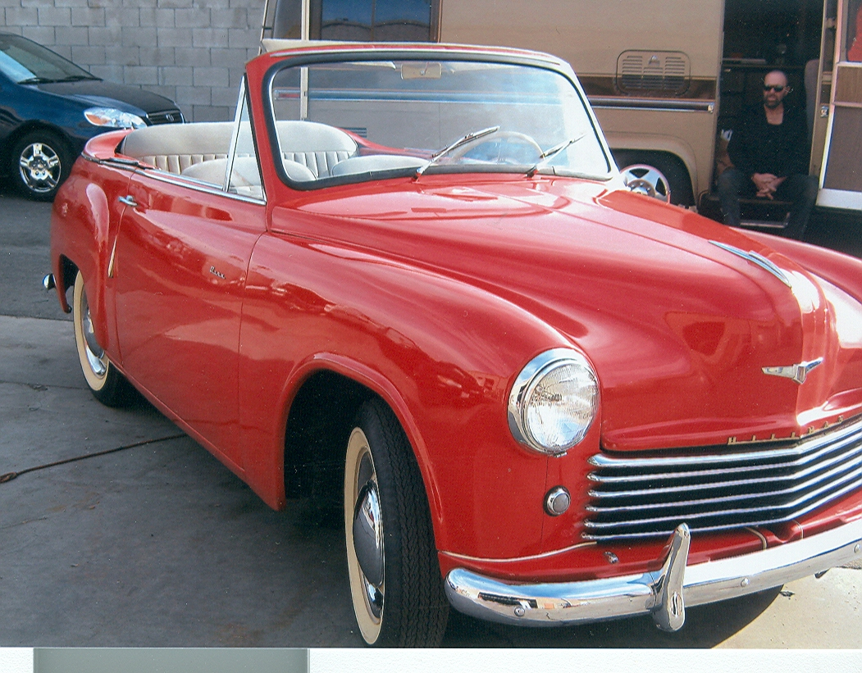

Mike’s really nice ’51 Minx in “Rose Bowl Parade Car” trim

Mike’s other Minx, the 1948 Phase II has been extensively modified to make it a comfortable and “fun” driver. I am not going to even try to guess how much was spent on this car or what it is worth, but here are two pictures of it….

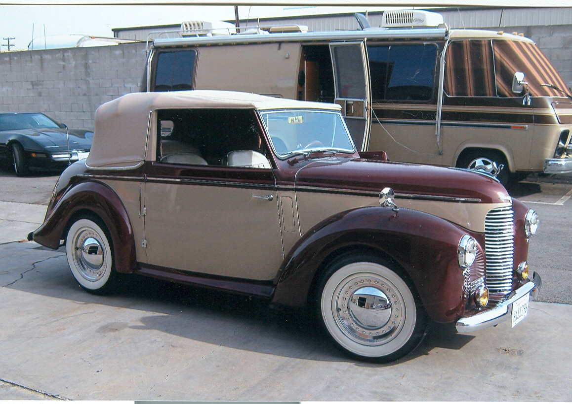

Side view of Mike’s car, not original colors but very tasteful with beautiful matching top

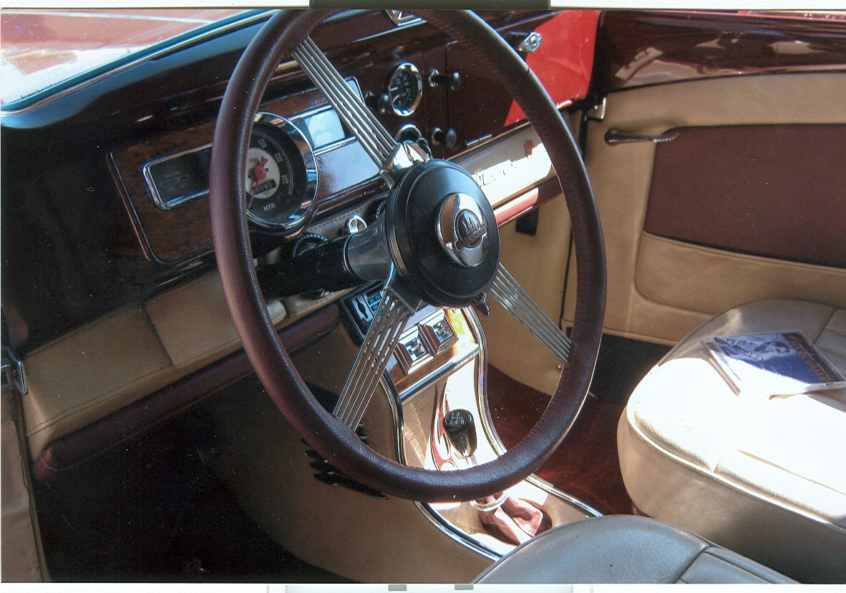

Definitely not a stock interior!

As can be seen from the interior shot, a lot has been done to this car. According to Mike….
It has an MG Midget 1265cc engine that has been hopped up, it has an MG overdrive transmission, a Chevette front suspension and a Chevette rear axle. Along with the Chevette suspension it also got power rack and pinion steering.

Although you can’t see them in the interior picture, there are a pair of vents for the Air Conditioning in the center of the dash. It has an IPOD player and a CD player and a 2000 Watt sound system (I wonder if the car slows down when you turn the sound system on?). Needless to say the interior is totally custom along with the console. The colors of the interior are maroon and bisquit.

In the power accessories department it has power seats, power windows and power disk brakes. To handle the heat generated by the engine it has an Audi Fox radiator and twin thermostatic fans cooling it.

The wheels and hubcaps are aftermarket Volkswagen items and under the hood the engine has lots of chrome! The car runs and goes with the big dogs while the AC freezes your buns off and the stereo plays Glen Miller Oldies.

Mike rescued the car from a junkyard 40 years ago with no drive-train, interior or trunk. The result is the beauty you see here.

Voltage Regulators, Part I
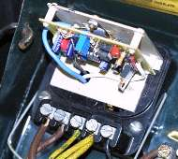
"Yes I do make solid-state conversions of Lucas regulators. I can do 5 post, 9 post, and I have done one for a recreation of a MGA Sebring race car being built in Fla. They fit in the Lucas cases so that they appear original. I can make them either positive or negative ground. They will have current limiting to protect the dynamo (generator) from burning itself out and temperature compensation for cold/hot weather voltage compensation. All in all very up to date, modern performance but within the limits of the dynamo installed.
To proceed I need a regulator to modify and info as to the generator it will be used with, so I know where to set the current limit. Also positive or negative ground. The price is $80 plus $5 shipping. The regulator need not operate, or even have it's original relays, it does need a base that is suitable for buffing to make it look better. At this time I have no way to refinish the terminals, or the fuse holders on a 9 post.
If this sounds like something of interest to you, email me and you can ship your regulator carcass to: Wilton Auto Electric
10 Stoney Brook Drive
Wilton N.H. 03086-5151
Put a note in the package confirming your order and giving me a return address to ship your regulator back to. Turn around is about 1 week. "Robert K. Jeffers" - <bobj50@comcast.net> - (603) 654-9852

Voltage Regulators Part II

Over the years Hillman used a number of different voltage regulators. Fortunately, except for the early ones, they are all interchangeable. The early regulators, used on the Phase II through the Mark IV used a Lucas “RF-95” regulator that included the fuse block. This type of regulator was usually called a “9 post” regulator. They are still available from Moss Motors for the MG TC and TD but cost a whopping $269.95 each. I suggest if you need to replace one of these you contact Bob Jeffers above!

The next regulator was the RB-106 and was used on the Mark V through the 1959 Series III Minx and Husky Mark I and Series I. This regulator had only 5 posts and they were “screw down” type. Moss Motors sells these for the MGA with a price of $59.95 for a cleaned and adjusted one and $39.95 for one needing the contacts cleaned and the unit adjusted (I suggest going for the more expensive one and save yourself the work). Starting in 1960 Minxes and Husky’s continued to use the Lucas RB-106 but these had “Lucar” push on connectors rather then the old bare wire screw down connectors. This type of regulator was used up through mid-way of the Series V. It is available from a number of suppliers, Classic Sunbeam Parts, Sunbeam Specialties and Victoria British all sell it for $75.90 and Moss Motors for a later MGA for $69.95 . Just a note, you can substitute one for the other, you just need to modify the connections on the wires.

In mid-production of the Series V Minx and Series III Husky the RB-106 regulator was replaced by the Lucas RB-340 regulator which regulated current as well as voltage. This unit is available from a number of places, ranging from Moss Motors (MG Midget for $29.95) to the various Sunbeam parts suppliers for about $60. If you use the Moss Motors one, it will be a non-Lucas replacement type (meaning it will not have the Lucas logo on the cover).

Finally there was another type of voltage regulator, the RB-310 used with the Easidrive cars. This unit appears to be exactly the same as the RB-340 except that it has a metal cover instead of a plastic one. If you have an Easidrive equipped car, you could use an RB-340 regulator, but you must adjust it for 30 amps instead of 22 amps (the generator on Easidrive equipped cars is a 30 amp generator, not the 22-25 amp one used on standard cars).

There is a still cheaper solution, in the mid-nineteen sixties Ford Tractors used Lucas generators and Lucas Voltage regulators. While the generators require a great deal of modification to fit (they have an odd-ball tach drive), the regulators are the standard RB-340 type which can replace the earlier RB-106. I currently have a non-Lucas RB-340 style replacing an RB106 in my 1962 Minx. To install the later type in an early Minx you will have to drill three mounting holes and use self-taping screws to mount the new regulator on the firewall. However, the RB-340 is a better regulator as it has three “spindles” rather then just two found in the RB-106. This means it regulates both Voltage and Current (the RB-106 only regulates voltage). There are a number of sources for this regulator- one is Tractor Parts Inc., PO Box 2187, Glasgow, KY 42142-2187 (270-678-9611) and the price is $20.25 plus shipping-order a D0NN10505A for a Ford 2000, 3000, 4000 series tractor. However, it is a non-Lucas regulator and the cover is plain without the “Lucas” logo. You could swap covers from your old Lucas RB-340 (or buy a bad unit cheaply at an auto flea market) to the new, non-Lucas regulator.

Hillman Parts For Sale:

Lucas Generator 22532 F, believed to be NOS, for later Easidrive or as a heavy duty replacement (would need special pulley) asking $20 plus shipping

Set of four NOS hubcaps, look like Minx but are 8 ½ inch diameter. Asking $20 plus shipping

Robert Willis, 4480 11.5 Road, Escanaba, MI 49829
Phone- 906-789-1257

